CLUB EWR KIWI CHAPTER
JUNE 2026

Fiesta Flight Royale Takes San Antonio by Storm!
The 36th Biennial Kiwi National Convention, aptly titled "Fiesta Flight Royale," was another soaring success! Held April 28th through May 2nd along the beautiful and famous San Antonio River Walk, the convention was filled with friendship, laughter, memories, and philanthropy, proving once again that Kiwi spirit still flies high!
This year’s convention honored the 50th Anniversary graduating classes of 1975–76, celebrating friendships and memories that have stood the test of time. We also proudly recognized the 30th Anniversary of WINGS as our National Endeavor, marking three decades of helping and supporting others.
The festivities officially took flight at the Opening Luncheon, where several Kiwi awards were presented. Club EWR had much to celebrate!
We are incredibly proud to announce that Club EWR received the prestigious Kay Hansen Award, a wonderful honor recognizing the spirit and accomplishments of our club.
Adding to our excitement, our own Gloria McGowan was awarded the highly respected KIWI Award, a truly special and well-deserved recognition of dedication and service. Congratulations, Gloria!
The luncheon also featured a fascinating presentation by Beverly Bass, American Airlines’ first female captain, whose stories and experiences inspired and entertained all in attendance.

Representing Club EWR in San Antonio was:
Nancy Waller, Gloria McGowan, Sherri King Grossman, Barbara Liptok,
Michelle Robertson, Diane Palmer, Sharon Laughlin, Marguerite Sensoli,
Vicki Van Meter, and of course, our beloved Sam Gooch!

Of course, convention fun extended far beyond the meeting rooms!
One memorable evening, attendees boarded a riverboat barge and floated down the magical River Walk en route to the famous Casa Del Rio Restaurant for dinner. The lights, music, and scenic ride made for a perfect San Antonio evening and plenty of photo opportunities.
Shopping enthusiasts found their happy place at the lovely boutique and silent auction, where Kiwi-themed treasures and merchandise made browsing and bidding especially fun. Between unique finds and friendly competition, the shopping scene added another layer of excitement to the week.
The celebration wrapped up with the Closing Banquet Dinner, complete with country music and dancing. But before the evening officially began, the Club EWR ladies created a memorable event of their own!
Decked out in our matching cowboy nightgowns, the EWR Kiwis gathered for a spirited photo session and perhaps a glass or two of wine before changing for the banquet festivities. There were lots of pictures, plenty of videos, and enough laughter to last until the next convention. Exactly the kind of memories Kiwi friendships are made of!
A heartfelt thank you goes to the Past National Board, the newly elected National Board, the Convention Chair and her hardworking crew, and all of the officers and volunteers whose dedication and countless hours made Fiesta Flight Royale such a fun and successful event. Pulling off a national convention is no small task, and we appreciate every detail that helped make this gathering so memorable.
And before we could even unpack our suitcase’s, exciting news was announced…
The next Kiwi National Convention will be held in Palm Springs!
So Kiwi friends, we officially have two years to get “swimsuit ready!” Until then, we'll treasure the memories, keep the laughter going, and continue letting our Kiwi friendships soar.
See you in Palm Springs!
Kiwi Hugs,
Sherri
CEK Chapter President
_{President} Secretary Treasurer/Sunshine person
_{Sherri King Grossman} _{Nancy Waller} _{Gloria McGowan}
_{skgrossman@yahoo.com} _{kiwinancywaller@aol.com} _{gmcgowan2000@aol.com}

Hello Kiwis!
I can’t wait to tell you how much fun I had at the convention. The 2026 Kiwi convention was held at the Contessa Hotel in San Antonio, Texas. It was a complete success. The planning was impeccable all the way up to the very last day.
The first full day started early with a delegates meeting. Our acting president, Sherri, and our treasurer, Gloria, represented our club EWR Kiwi chapter.
Following was the awards luncheon. Our guest speaker was our own retired Captain Beverly Bass. She kept us mesmerized while she told us of her life’s dream to become an airline pilot and all she had gone through to reach her goal.
During the awards presentation, our club EWR Kiwi chapter was awarded a distinct award. It was called the Kay Hansen trophy award for our charitable work. Also, our well-deserving, and very special treasurer and sunshine committee chairperson, Gloria McGowan, was awarded a Kiwi award for all of her contributions to our club EWR Kiwi Chapter.
At this time, we all remember and thank Ginny, our past president, for her strong leadership during the past few years. We only wish she could’ve been here to accept the Kay Hansen award for which she’s so deserved. We took Ginny‘s cowgirl hat with us and took turns during the convention wearing it. It truly was our honor to have her with us in this small way.
Later that evening, we took a photo shoot with a very famous llama, enjoyed cocktails, and boarded boats to take a tour of the Riverwalk before docking at a fabulous Mexican restaurant. We all talked about how great everything was, especially the Mexican delicacies.
Late in the evening, a violent storm ripped through San Antonio. The weather easily confined our daytime dining to indoors at the hotel restaurant.
By 4 o’clock our happy hour began by enjoying champagne, while donning our cowgirl hats, boots, and our preplanned matching nightgowns. We started this tradition two years ago in Savannah, Georgia. We ended our happy hour by singing the famous song, “We’re American Airlines doing what we do best!” We then packed up our hats and boots and went back to our rooms and proceeded to get decked out in our finest “gala” wear! We made sure our shoes were good for all the dancing we had planned to do during the evening. We ended up dancing all night to a wonderful band, even forming conga lines that continuously snaked around the tables.
After dining and enjoying our many libations, the band was packing up to leave when suddenly over the audio system came another favorite song, “Leaving on a jet plane”! Smiling, singing, and hugging each other we promised we would be at the next convention in two years in Palm Springs, California!
So come on Club EWR Kiwis get ready for another great get together in two years.
Hugs!
Nancy
Secretary


The 2026 Convention in San Antonio, TX was fabulous. The Contessa Hotel was on the Riverwalk and our rooms were beautiful suites, complete with mini fridge and coffee maker. Lots of activities. Our luncheon featured Beverly Bass highlighting her career and landing at Gander Air Force Base after 9-11. Her daughter also was in attendance and is following in her mother's footsteps. We had a river cruise and dinner at a Mexican restaurant. In our free time we got together for our matching pajama party, and sang songs.

The highlight for me was receiving the Kiwi Award for outstanding service and dedication to Club EWR. I love being a part of Club EWR. It's not work, but a rewarding experience.

We had our regular meeting on May 13th. We collected charitable donations, dues monies and enjoyed lunch with everyone.

Gloria
Sunshine Lady/Treasurer

June Birthdays CEK
06-10 – Sherri King Grossman
06-10 – Betty Wormley
06-27 – Barbara Kimoto-Berg
06-20 – Diana Schauberger Smith
06-30 – Marguerite Sensoli
July Birthdays
07-25 – Gayle Kocak

THANK YOU THANK YOU THANK YOU…
It’s been quite a while since my wonderful Kiwi’s gifted me
with their $5000.00 “go fund me” check. I was so overwhelmed I choked and really didn’t know what to say! I thank ALL – each and every one of you from the bottom of my heart, you showed me so much love and kindness I’ll never forget. Please know how humbled I am, and you made me so happy and proud! I have it in a special saving account so when the time comes and I have a permanent home in which to live, I shall be able to put it to great use!!!
I LOVE you ALL,
THANK YOU SO MUCH !!! 💋 💕
Kathy Brodrick 😢
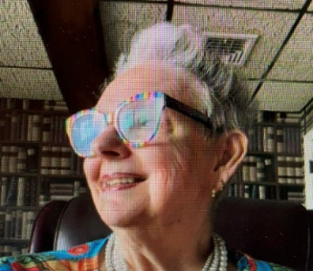
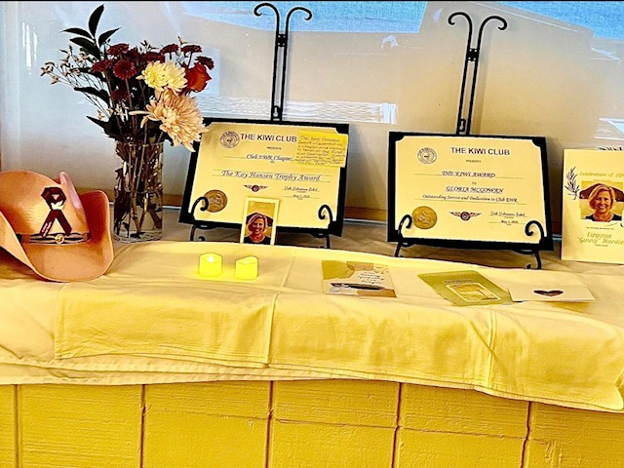
Kay Hansen Trophy award
Awarded to Club EWR Kiwi Chapter
Awarded to a chapter and named in honor of the first Kiwi Counselor. It is presented to a chapter for its facilitation of uplifting charitable acts.

Gloria McGowan
The Kiwi Award
The Kiwi Award is granted to honor and recognize an individual Kiwi or organization for continuous – not less than five years – dedication, assistance, support, or promotion of a local Kiwi chapter or The Kiwi Club. This is the most prestigious award that a chapter can bestow on a member, MAL or a person/organization whose performance has been outstanding.

And Always, we are Remembering Ginny…

The Kiwi Convention 2026, San Antonio, TX
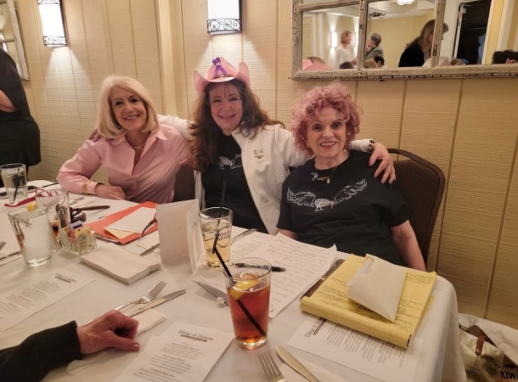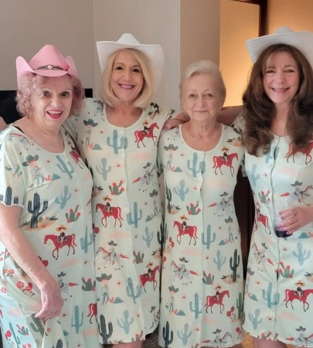
Nancy, Sherri and Gloria Gloria, Nancy, Barbara and Sherri
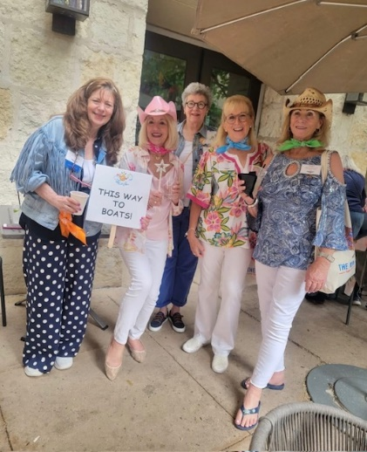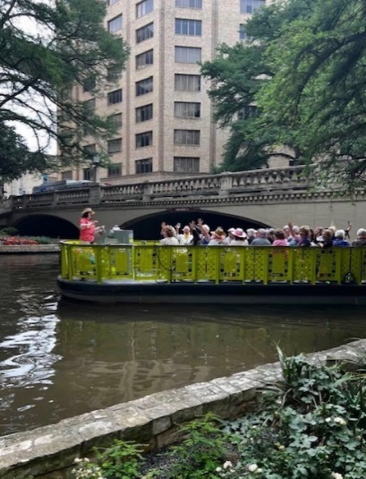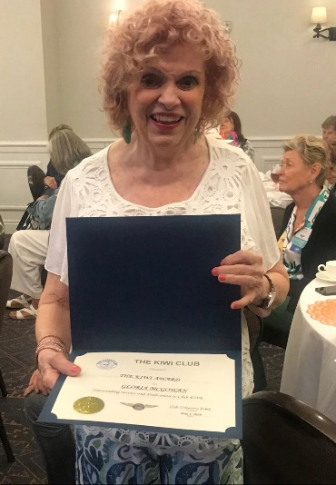
Sherri, Nancy ( ) Sharon San Antonio Riverboat Gloria and her
And Michelle Kiwi Award
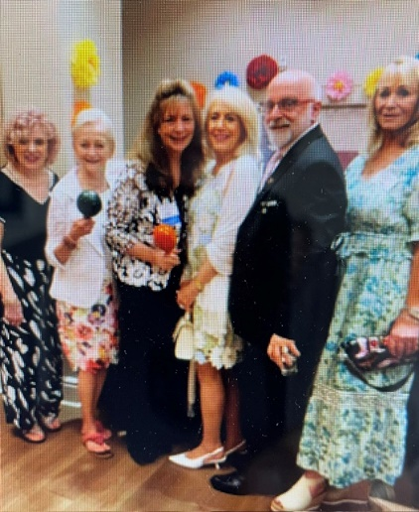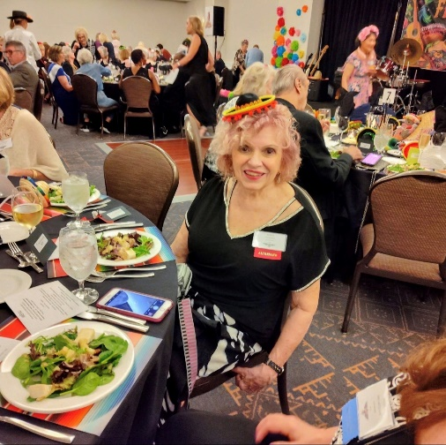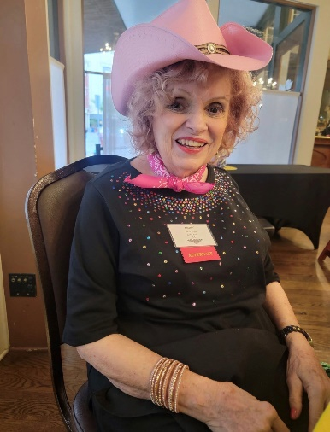
Gloria, Barbara, Sherri, Gloria Gloria
Nancy, Sam and Michelle
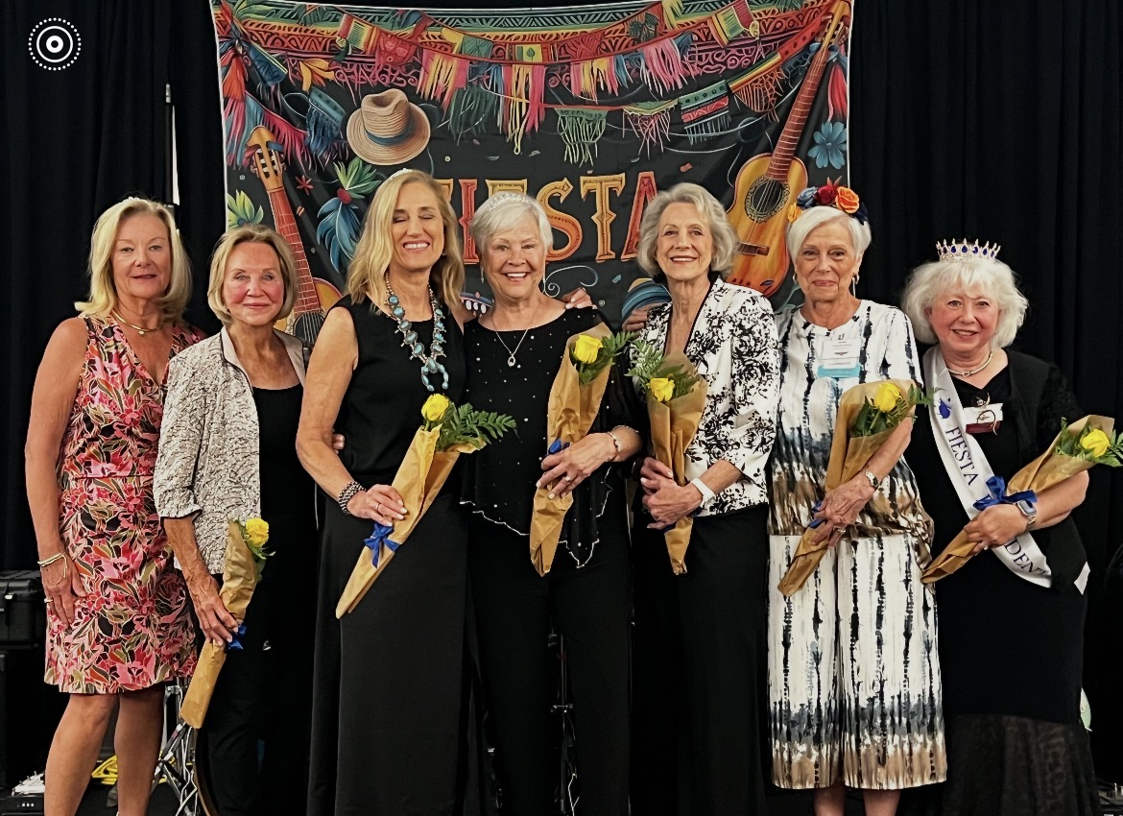
(L TO R) 2026-2028 National Executive Board: Stephanie McCauley Butler, Advisor, Linda Hessler Radke, VP, Melissa Williams McGrath, President, Kathy Schmidt Kuzminski, 2nd VP, Martha Freeman Cunningham, Secretary, Wanda Barry Kromer, Treasurer and Vicki Valenciano Kubal, Past President.
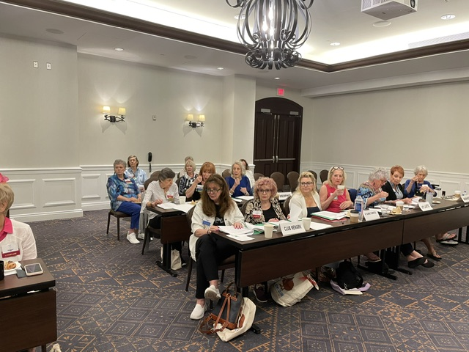
Sherri and Gloria at the Delegates meeting May 1, 2026
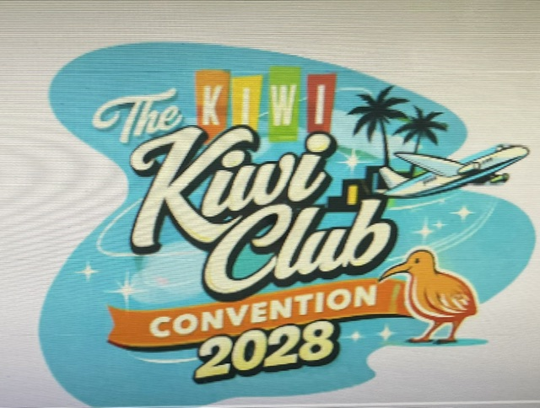

Start planning now for the 2028 Kiwi Convention in
Palm Springs, May 2028

